CA – II ASSIGNMENT

GEN-AI

Name : Rutuja Durge PRN: 21070521062

Semester : 7 Section : A

Q:6 Generate a model to represent a mathematical equation, write a program to parse the equation, and ask for input for each parameter.

**Model Code:**

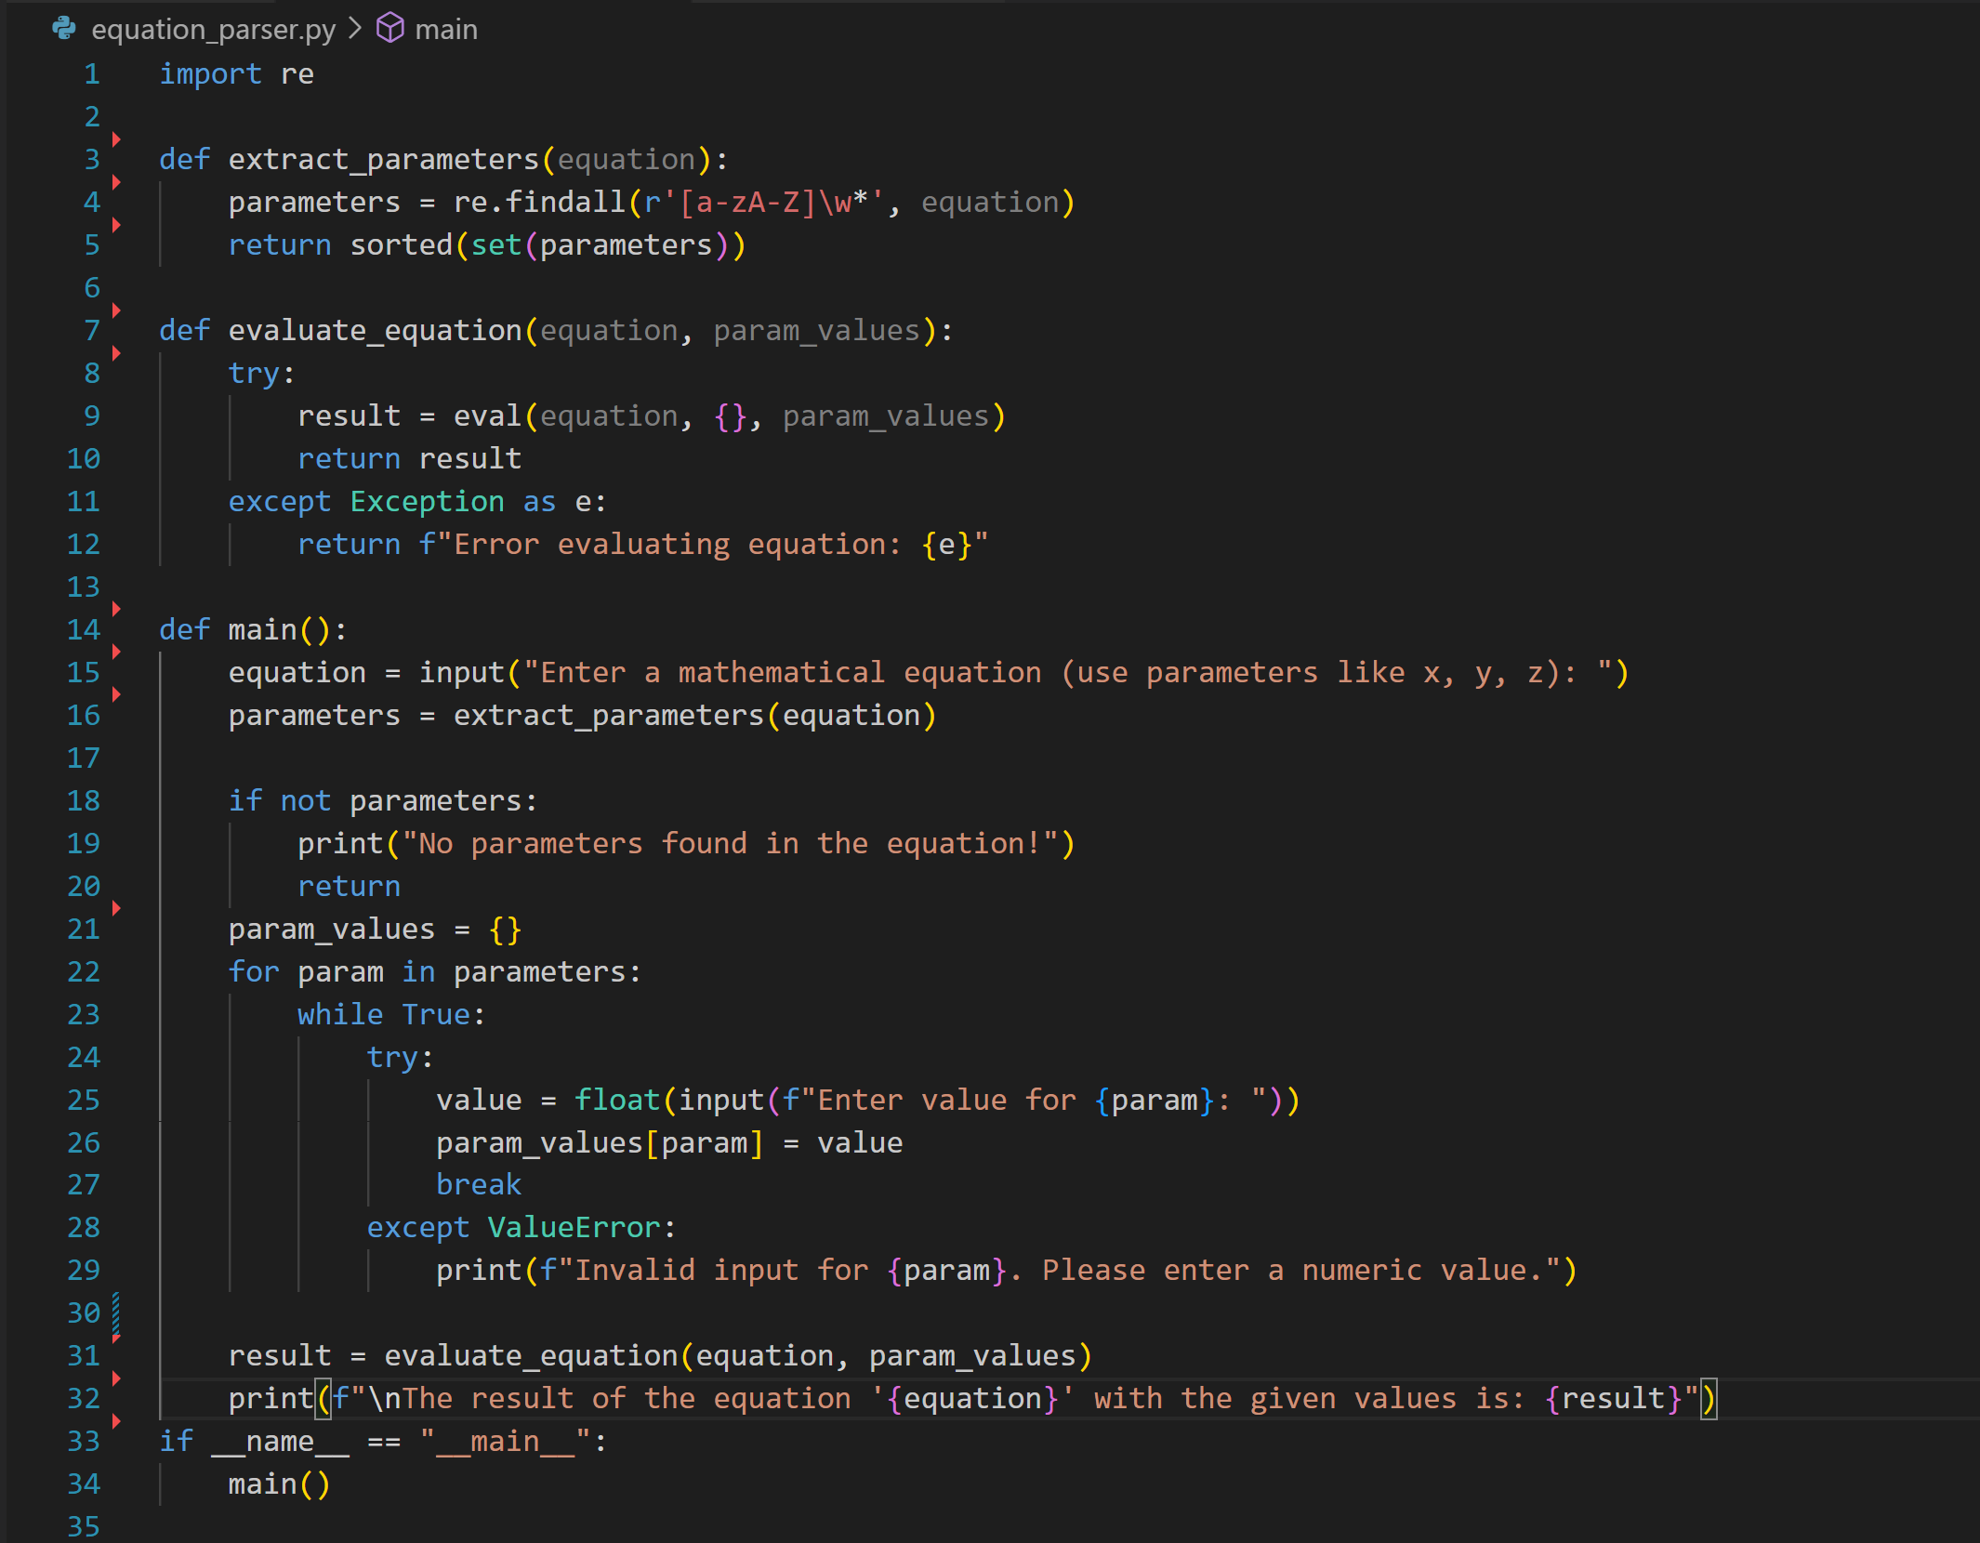

**OUTPUT:**

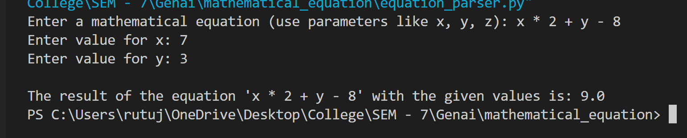

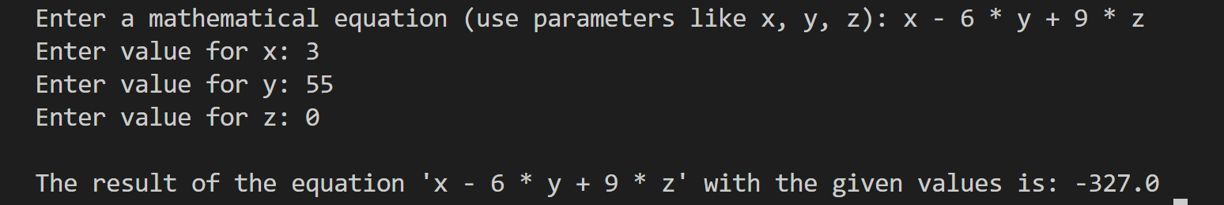

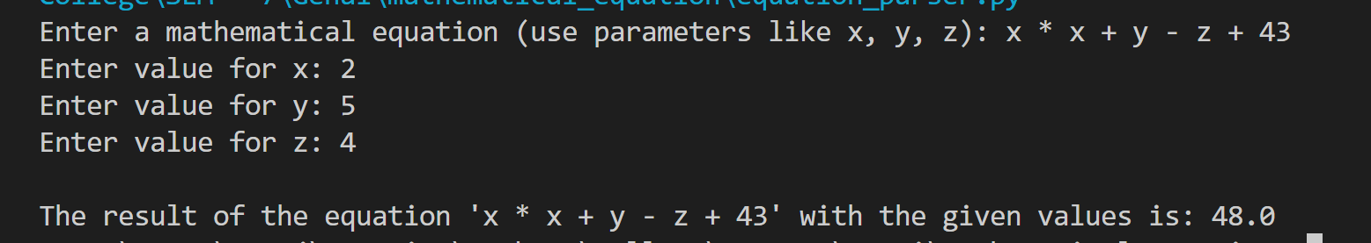

**Explaination Of Code:**

This Python code allows the user to input a mathematical equation with parameters (such as x, y, z), assigns values to those parameters, and then evaluates the equation using the provided values.

Code Breakdown:

1. extract_parameters(equation):
   * Uses regular expressions (re.findall) to find all unique parameters (variable names) in the equation.
   * The pattern r'[a-zA-Z]\w*' looks for alphabetic characters followed by alphanumeric characters or underscores, capturing variables like x, y1, z_value, etc.
   * The function returns a sorted list of unique parameters.
2. evaluate_equation(equation, param_values):
   * This function evaluates the mathematical equation using the built-in eval() function, which computes the result of the expression.
   * It takes a dictionary param_values that contains the parameter names as keys and their respective values.
   * The eval() function is used inside a try-except block to catch any errors that occur during the evaluation (e.g., if an invalid equation or values are provided).
3. main():
   * Prompts the user to input a mathematical equation containing parameters (e.g., x + y or x * z - y).
   * The extract_parameters() function is called to identify the parameters used in the equation.
   * For each parameter, the user is prompted to enter a numeric value. This input is validated to ensure that it is a valid float.
   * Once all parameter values are provided, the equation is evaluated using evaluate_equation().
   * The result is then printed.

Example:

If the user inputs:

* Equation: x * y + z
* x = 2, y = 3, and z = 4

The result will be 2 * 3 + 4 = 10.